New York City Nails
@
Belfast International Airport

Are pleased to offer the following discount to
Kickhams Creggan GAC members

Full set of Acrylic nail extensions £25*

Offer valid from 3rd – 17th October 2008

Appointments advisable, contact salon @ 028 94484328

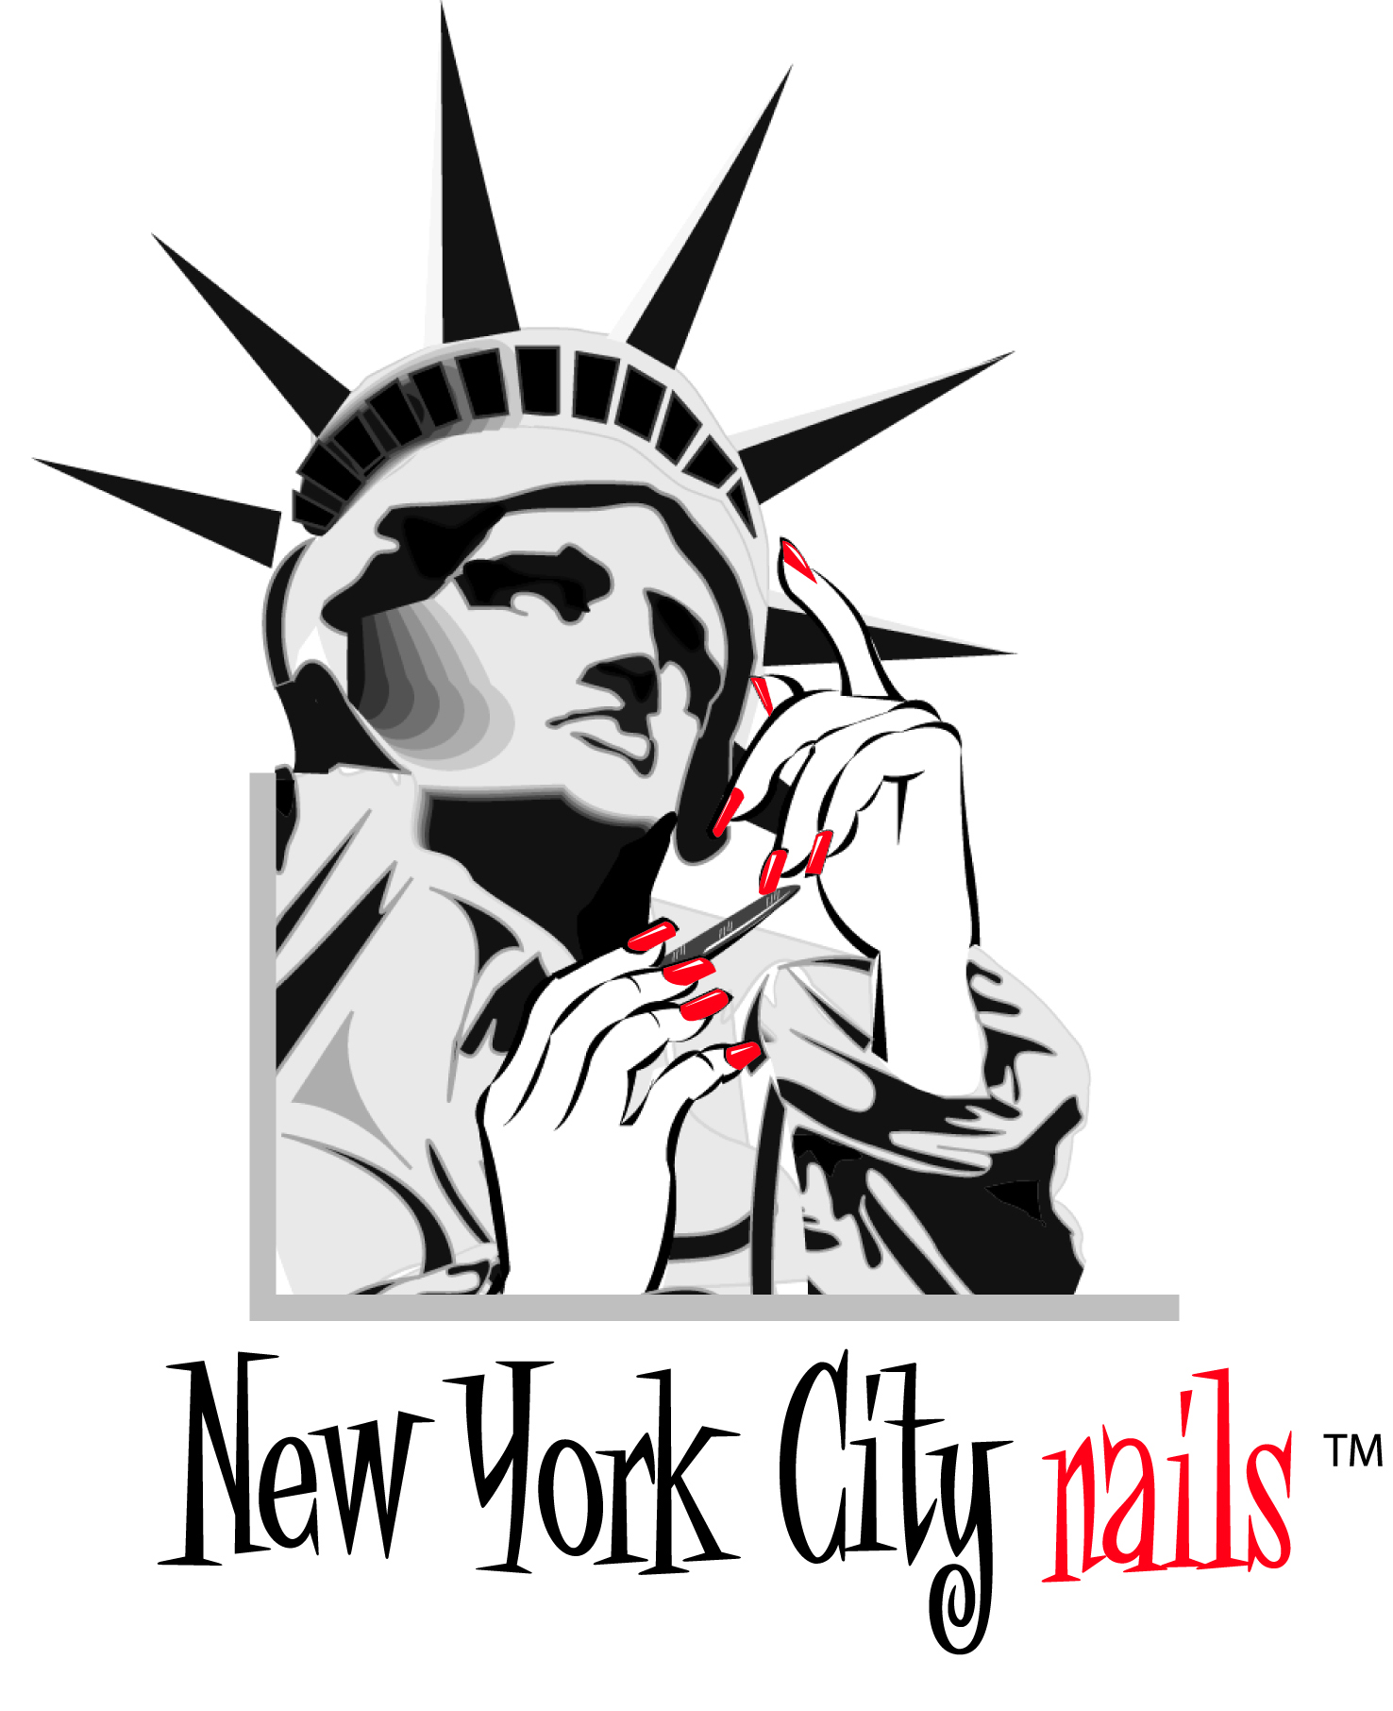
*Only available at NYCN Belfast International Airport.
Not redeemable against any other service

